
KAUNAS UNIVERSITY OF TECHNOLOGY
FACULTY OF INFORMATICS
T120B166 Development of Computer Games and Interactive Applications

Banisher

IFF-7/11 Deividas Verbickas
Date: 2020-03-02

Kaunas, 2020
Table of Contents
Table of Images 3
Table of functions 4
Work Distribution Table: 5
Description of Your Game 6
Laboratory work #1 7
List of tasks 7
Solution 7
1. First level design 7
2. VR player controller 8
3. Added more GameObjects 8
4. VR interactions with environment objects 9
Laboratory 1 defense 9
Laboratory work #2 9
List of tasks 10
Solution 10
Task #1. Title of Task 10
Task #2. Title of Task 10
Task #3. Title of Task 11
Laboratory work #3 13
List of tasks 13
Solution 13
Task #1. Title of Task 13
Task #2. Title of Task 13
Task #3. Title of Task 14
User's manual 16
Literature list 17
ANNEX 18

Table of Images
Figure 1. First level design 7
Figure 2. added more game objects 8
Figure 3. VR interaction with objects 9
Figure 4. Screenshot #1 10
Figure 5. Screenshot #2 11
Figure 6. Screenshot #3 11
Figure 7. Screenshot #1 13
Figure 8. Screenshot #2 14
Figure 9. Screenshot #3 14
Figure 10. Screenshot #5 16
Figure 11. Screenshot #5 16

Table of functions
Table 1. Title of fragment #1 10
Table 2. Title of fragment #2 11
Table 3. Title of fragment #3 12
Table 4. Title of fragment #1 13
Table 5. Title of fragment #2 14
Table 6. Title of fragment #3 15

Work Distribution Table:

Name/Surname | Description of game development part
Mantas Klimašauskas | Programming
Deividas Verbickas | Programming, level design

Description of Your Game

Description of Your Game.
- 3D or 2D? 3D
- What type is your game? Action.
- What genre is your game? Fighting.
- Platform? PC.
- Scenario Description. A fighting game where the player has the ability to enter a separate mirror dimension.
The dimension is called the Exsilium and the one who can enter it are called outcasts (exsul). In the Exsilium you can see and touch (and even affect) the real world. Time moves slower in the Exsilium relative to the real world, which gives an advantage to anyone who is in it. In order to stay in the Exsilium the outcast must use their Vis (energy). The more matter the outcast takes to the mirror dimension the more Vis is being used. Also, the outcast uses more energy the further away they are from their physical body (in the real world). Vis is also directly related to stamina of the outcast in the real world.
Inside the Exsilium outcasts can use their energy to acquire buffs, such as super strength.
Most of the enemies encountered by the player do not possess the power to enter use the Exsilium to their advantage. But there will be bosses, who will be just as capable (or even stronger) than the player. Anyone who is damaged while in the mirror dimension cannot be killed and simply loses their energy. In order to regain the energy, the outcast must use special items.

Laboratory work #1

List of tasks
- First level design
  - (Create a small demo level using tiles, sprites or 3D objects)
- VR player controller
  - (Create your own game Character with own Controller script, make it move and jump (you can use Rigidbody Velocity or Force, Input.GetAxis, Input.GetTouch))
- Added more GameObjects
  - (Decorate your World, start adding more GameObjects (at least 20), include some lights (at least 5), make some materials for Objects to look different (at least 5))
- VR interactions with environment objects
  - (Make a new GameObject that’s a Sprite or a 3D Object, give it a Collider, use OnCollisionEnter to track when your Player touches it, then destroy it and print out a message that says “Player touched me”)

Solution

First level design
Created a somewhat open city, where the player can traverse the open streets to complete the level. Added a “secret” side area where the player will be able to get a powerup (work in progress), also added temporary roadblocks (red busses), so the player won’t wander off.
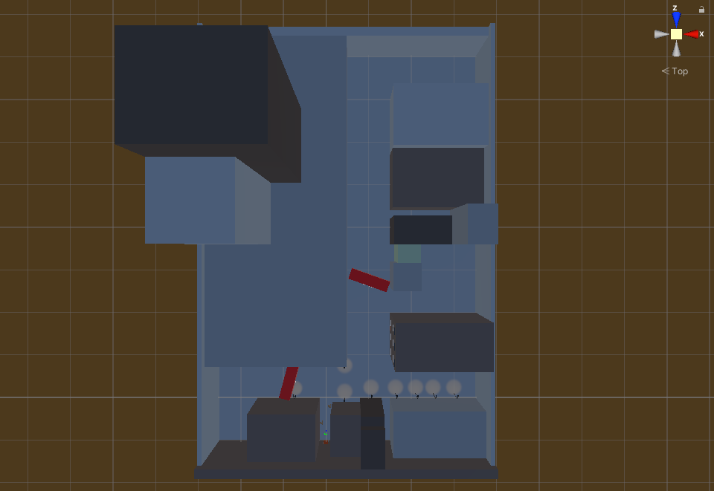
Figure 1. First level design

VR player controller
Imported SteamVR plugin for Unity and adjusted the relevant settings, for SteamVR to properly run. Made sure that it works properly with VR hardware (headset and hand controllers). I used windows mixed reality HMD (head mounted display) to test out the player controller. An alternative was that it added keyboard and mouse translations to the camera and movement for basic testing and left mouse click for object interaction.

Added more GameObjects
Added multiple objects to buildings (windows, open and closed doors), added streetlights and randomly placed boxes on the streets. Added multiple building materials, unique materials for windows and light poles etc.
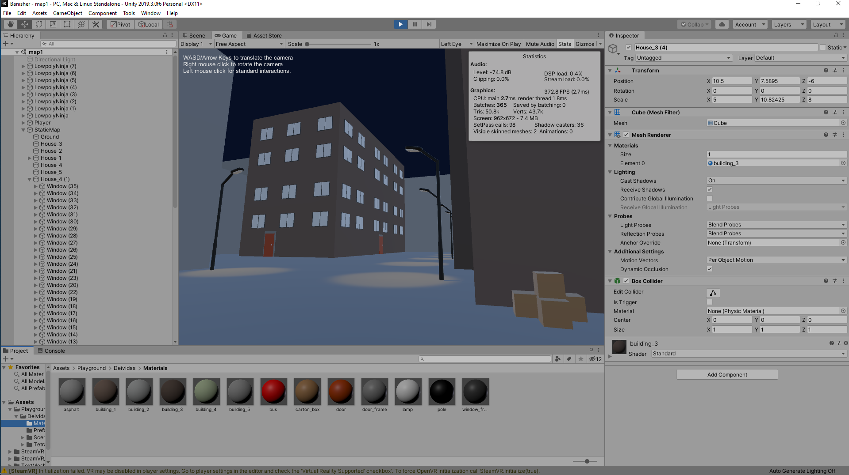
Figure 2. added more game objects

VR interactions with environment objects
Added relevant SteamVR plugin components to the relevant “interactable” objects and made sure they work properly with the virtual hands.
In order to make objects physically interactive, I’ve added a “Throwable” component to the box objects and changed the necessary “Attachment Flags”: DetachFromOtherHand and VelocityMovement
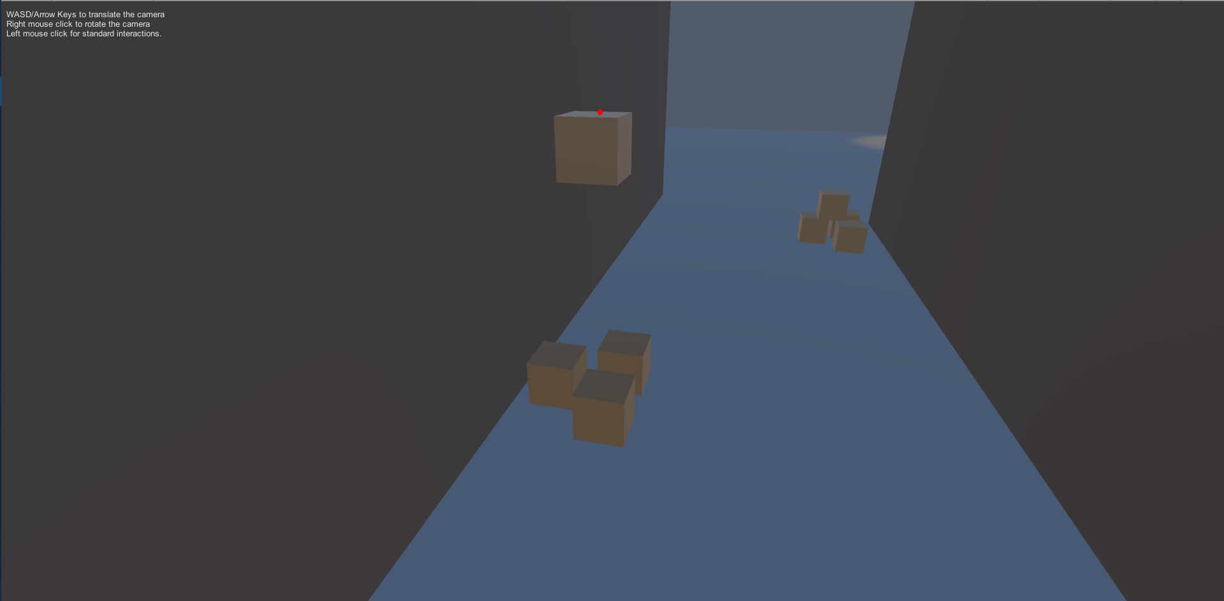
Figure 3. VR interaction with objects

Laboratory 1 defense
Task: create a cube and add baked different lights to each side of the cube.
Solution:
- Create a new object (GameObject -> 3D Object -> Cube),
- Make the cube static (In the inspector tab select the “static” checkbox).
- Add Area Lights (Window -> Rendering ->Light Settings -> check the “Auto Generate” checkbox) and in the inspector tab change the color.
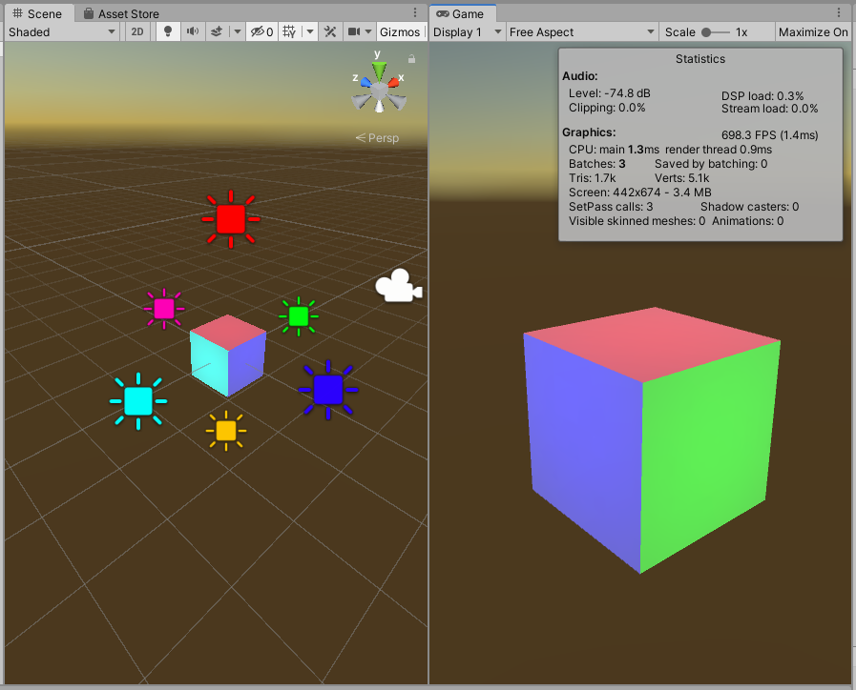

Laboratory work #2

List of tasks (main functionality of your project)

- Title of Task #1
- Title of Task #2
- Title of Task #3
- …

Solution

Task #1. Title of Task
Description of implementation (3-5 sentences). Vestibulum hendrerit felis at turpis ultrices imperdiet. Nulla facilisi curabitur vitae semper nulla. Etiam rhoncus orci dolor, ac dictum erat iaculis sed. Aliquam pulvinar viverra consequat. Nam eu mi in mauris semper pellentesque eget ut erat.

Screenshot
Figure 4. Screenshot #1

In the case of using functions, the description of each main function should be completed with the source code FRAGMENTS (the functions should be indexed in a separate table of contents);
Fragment of Source Code
Table 1. Title of fragment #1

Task #2. Title of Task
Description of implementation (3-5 sentences). Lorem ipsum dolor sit amet, consectetur adipiscing elit. Sed ultricies nunc sit amet sem blandit, at ultricies nibh commodo. Duis ut mollis risus. Proin hendrerit libero eu felis dapibus imperdiet. Fusce posuere felis ornare luctus molestie. Duis ut odio pretium, bibendum elit et, molestie quam.

Screenshot
Figure 5. Screenshot #2

In the case of using functions, the description of each main function should be completed with the source code FRAGMENTS (the functions should be indexed in a separate table of contents);
Fragment of Source Code
Table 2. Title of fragment #2

Task #3. Title of Task
Description of implementation (3-5 sentences). Vestibulum hendrerit felis at turpis ultrices imperdiet. Nulla facilisi curabitur vitae semper nulla. Etiam rhoncus orci dolor, ac dictum erat iaculis sed. Aliquam pulvinar viverra consequat. Nam eu mi in mauris semper pellentesque eget ut erat.
Screenshot
Figure 6. Screenshot #3

In the case of using functions, the description of each main function should be completed with the source code FRAGMENTS (the functions should be indexed in a separate table of contents);
Fragment of Source Code
Table 3. Title of fragment #3
Laboratory work #3

List of tasks (main functionality of your project)

- Title of Task #1
- Title of Task #2
- Title of Task #3
- …

Solution

Task #1. Title of Task
Description of implementation (3-5 sentences). Vestibulum hendrerit felis at turpis ultrices imperdiet. Nulla facilisi curabitur vitae semper nulla. Etiam rhoncus orci dolor, ac dictum erat iaculis sed. Aliquam pulvinar viverra consequat. Nam eu mi in mauris semper pellentesque eget ut erat.

Screenshot
Figure 7. Screenshot #1

In the case of using functions, the description of each main function should be completed with the source code FRAGMENTS (the functions should be indexed in a separate table of contents);
Fragment of Source Code
Table 4. Title of fragment #1

Task #2. Title of Task
Description of implementation (3-5 sentences). Lorem ipsum dolor sit amet, consectetur adipiscing elit. Sed ultricies nunc sit amet sem blandit, at ultricies nibh commodo. Duis ut mollis risus. Proin hendrerit libero eu felis dapibus imperdiet. Fusce posuere felis ornare luctus molestie. Duis ut odio pretium, bibendum elit et, molestie quam.

Screenshot
Figure 8. Screenshot #2

In the case of using functions, the description of each main function should be completed with the source code FRAGMENTS (the functions should be indexed in a separate table of contents);
Fragment of Source Code
Table 5. Title of fragment #2

Task #3. Title of Task
Description of implementation (3-5 sentences). Vestibulum hendrerit felis at turpis ultrices imperdiet. Nulla facilisi curabitur vitae semper nulla. Etiam rhoncus orci dolor, ac dictum erat iaculis sed. Aliquam pulvinar viverra consequat. Nam eu mi in mauris semper pellentesque eget ut erat.

Screenshot
Figure 9. Screenshot #3

In the case of using functions, the description of each main function should be completed with the source code FRAGMENTS (the functions should be indexed in a separate table of contents);
Fragment of Source Code
Table 6. Title of fragment #3
User's manual (for the Individual work defence)

How to play? Aenean eu quam gravida, laoreet nisl eu, sagittis quam. Donec sit amet nunc nisi. Sed vel ipsum metus. Nullam accumsan vestibulum ex. Aenean eu quam gravida, laoreet nisl eu, sagittis quam. Donec sit amet nunc nisi. Sed vel ipsum metus. Nullam accumsan vestibulum ex.

Screenshot
Figure 10. Screenshot #5

Nunc vel enim vel magna interdum dapibus id nec nisl. Suspendisse elit augue, accumsan tempor erat sed, gravida suscipit urna. Duis blandit lacus et finibus finibus. Mauris pretium pharetra orci dictum luctus. Nullam commodo magna a tincidunt malesuada.

Screenshot
Figure 11. Screenshot #5

Sed sollicitudin justo erat, viverra luctus mi consequat non. Sed ut condimentum libero. Duis rutrum lacus ante, vitae feugiat ex faucibus at. Maecenas pulvinar et augue sed commodo.

Descriptions of the rules of the game. Nunc quis condimentum lacus. Quisque felis neque, ullamcorper vel posuere eget, blandit non neque. Nam in varius erat. Duis molestie sit amet eros vel rhoncus. Nunc quis condimentum lacus. Quisque felis neque, ullamcorper vel posuere eget, blandit non neque. Nam in varius erat. Duis molestie sit amet eros vel rhoncus.

Descriptions of the controls / keys. Donec et lorem vitae ligula bibendum faucibus. Suspendisse interdum quis augue sed luctus. Curabitur ac diam augue. In hac habitasse platea dictumst. Curabitur maximus maximus tortor. Nunc quis condimentum lacus. Quisque felis neque, ullamcorper vel posuere eget, blandit non neque. Nam in varius erat. Duis molestie sit amet eros vel rhoncus.

Literature list
- Source #1. Url
- Source #2. Url
- ...
- Source #N. Url

ANNEX
All source code is contained in this part.

